KWAMILI ESTATE

Producers of high quality Criollo cocoa beans since 1924

Kwamtili Estate in the East Usumbara Mountains some 40 km from Tanga in Tanzania dates from pre-World War 1 times. The estate originally covered over 5,000 hectares of which some 1,150 hectares were planted with kapok, derris, cocoa, oil palms, and rubber. After the World War 1 the estate was neglected until the 1950’s when it was acquired by the Tamé family. In 2003 Dennis Fielder became the majority shareholder and Managing Director. Upon his death in 2021, Dennis Fielder’s wife Latifa Fielder became the majority shareholder and was appointed Managing Director.

Kwamtili Estate Ltd. was registered in the 1960’s and the company’s offices are located at Street No. 11 in central Tanga. The company owns the Title to Occupation of the area known as Kwamtili Estate.

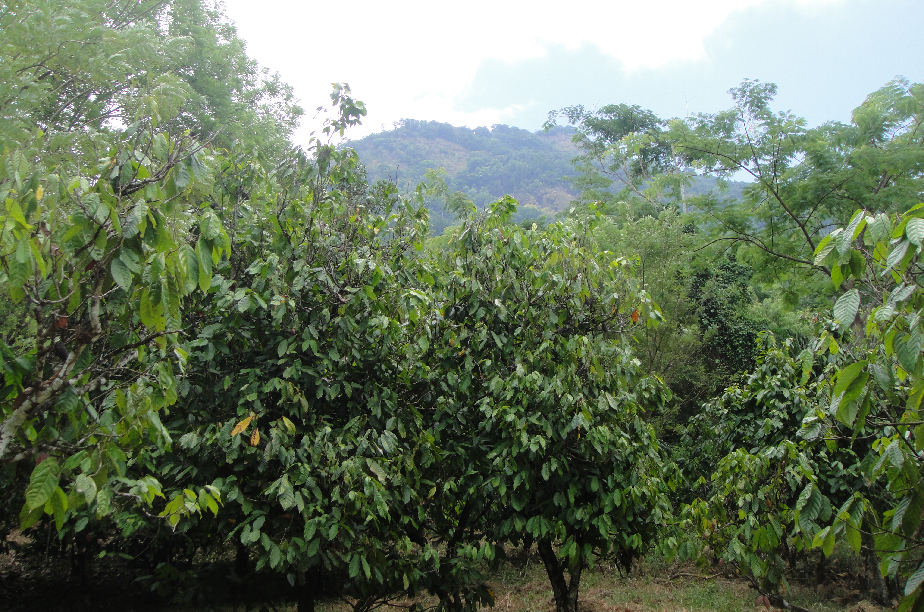

Kwamtili’s Criollo cocoa grows under the forest canopy on the foothills of Kwachawa Mountain in the East Usumbara Mountains, Tanzania.

Today, the estate covers 1,150 hectares of which 30 hectares of cocoa planted under the original forest canopy yields some 10 tonnes on dried Criollo cocoa bean. The estate’s forest adjacent to the cocoa growing area extends up and over the Kwachawa Mountain, an area of outstanding natural beauty and one of the world’s richest ecosystems that borders major forest reserves.

The 50 square kilometre forest area comprising Kwamtili, Kwamgumi Forest Reserve, Segoma Forest Reserve and the Bamba Ridge Forest Reserve that is centred on the Kwachawa, Segoma and Lukindo mountains is in fact the largest forested area in the entire Usumbara Mountains.

Our challenges

Four major types of cocao are cultivated around the world: Criollo, Forastero, Trinitario, and Nacional. Kwamtili’s Criollo cocoa is unique in East Africa, and possibly along the entire eastern seaboard, except for some Criollo that is grown on the island of Madagascar.

The Criollo tree, which originated in Central America, is still mainly cultivated in South and Central America. The yield is fairly low but by being very aromatic and lacking bitterness Criollo cocoa commands a very much higher price than the other varieties. Criollo is used in luxury chocolates but rarely alone since it is very scarce and expensive and becoming less and less available (it represents less than 3% of the world's cocoa production).

Kwamtili’s cocoa is picked and processed by an experienced group of local people, many of whom were formerly employed by the estate. Most now live in Kwamtili village that is located on the western side of the Muzi River, Tanga’s main water catchment source that acts as the estate’s western boundary.

Criollo cocoa trees are low yielding, susceptible to many diseases and considered rare in cultivation – challenges that Kwamtili has successfully overcome for several decades (Kwamtili’s Criollo was introduced by Dutch families that migrated from Indonesia to Tanzania in the 1920’s).

Our processing and exports

Kwamtili has for many years exported its cocoa to Europe, selling to Swiss chocolate makers through a Swiss-based broker with container shipment from Tanga to Amsterdam.

Shelled cocoa beans processed in Kwamtili’s factory are washed, fermented in wooden boxes, sun dried on special perforated aluminium alloy sheets, and dried in a special wood fired oven. Dried bean is stored in bulk for no longer than several weeks before grading and packaging in labelled sisal bags and shipment by container.

Our cultivation

Kwamtili is also unique by the virtue of the fact that cocoa trees are grown from grafts, which is the basis of the preferred method for Criollo in order to develop a hardy root system that is optimised for the local conditions. Grafting takes great skill since it requires considerable knowledge about the types of rootstock and cuttings that survive in northern Tanzania’s climate and soil.

Kwamtili takes great pride in keeping alive the remarkable skills needed to perpetuate the cultivation of an ancient and highly valued crop.

Our main issue

Extensive encroachment, mainly owing to ill-advised authorisation by a local Director, has led to the extensive destruction of forested areas along both sides of the estate’s main access road. Other areas are suffering from clearance, nominally for new cocoa plantation, but with no preparatory activity such as the growing of seedlings. The 15 families comprising former estate workers are organised as the Kwamtili Association to provide security in exchange for a licence to pick and process Kwamtili cocoa.

For information

For information, please contact Latifa Fielder (streetno11@gmail.com), Managing Director or Bakari Ali (bakarisoap@gmail.com), Administrative Assistant, Kwamtili Estate Ltd., P.O. Box 120, Tanga, Tanzania.

Further details: peterboswell.com/blog/kwamtili-estate-tanzania

April 2022

